APNA CloseT  
A PROJECT REPORT  
BY

TEAM NO. 01

Akshat Aggarwal (E22CSEU0020)

Rakshit Garg (E22CSEU0029)

Rohan Dabas (E22CSEU0013)

Arnim Saxena (E22CSEU0015)

SUBMITTED TO

SCHOOL OF COMPUTER SCIENCE ENGINEERING AND TECHNOLOGY, BENNETT UNIVERSITY

GREATER NOIDA, 201310, UTTAR PRADESH, INDIA

April 2024

# DECLARATION

We hereby declare that the work which is being presented in the report entitled “Apna Closet”, is an authentic record of our own work carried out during the period from January 2024 to April, 2024 at School of Computer Science and Engineering and Technology, Bennett University Greater Noida.

The matters and the results presented in this report has not been submitted by us for the award of any other degree elsewhere.

Signature of Candidates

Akshat Aggarwal

(Enroll. No. E22CSEU0020

Rakshit Garg

(Enroll. No. E22CSEU0029)

Rohan Dabas

(Enroll. No. E22CSEU0013)

Arnim Saxena

(Enroll. No. E22CSE0015)

# ACKNOWLEDGEMENT

We would like to take this opportunity to express our deepest gratitude to our mentor, **Dr. Umesh Gupta** for guiding, supporting, and helping us in every possible way. We were extremely fortunate to have him as our mentor as he provided insightful solutions to problems faced by us thus contributing immensely towards the completion of this capstone project. We would also like to express our deepest gratitude to VC, DEAN, HOD, faculty members and friends who helped us in successful completion of this capstone project.

Signature of Candidates

Akshat Aggarwal

(Enroll. No. E22CSEU0020)

Rakshit Garg

(Enroll. No. E22CSEU0029)

Rohan Dabas

(Enroll. No. E22CSEU0013)

Arnim Saxena

(Enroll. No. E22CSE0015)

**TABLE OF CONTENTS**

LIST OF TABLES 4

LIST OF IMAGES...........................................................................................................................4

LIST OF FIGURES 5

ABSTRACT 6

1. INTRODUCTION 7

1.1. Problem Statement 8

2. Background Research 9

2.1. Proposed System 10

2.2. Goals and Objectives 12

3. Project Planning 13

3.1. Project Lifecycle 13

3.2. Project Setup 13

3.3. Stakeholders 13

3.4. Project Resources 14

3.5. Assumptions 14

4. Project Tracking 15

4.1. Tracking 15

4.2. Communication Plan 15

4.3. Deliverables 16

5. SYSTEM ANALYSIS AND DESIGN 17

5.1. Overall Description 17

5.2. Users and Roles 17

5.3. UML diagrams 18

5.3.1. Activity Diagrams 19

5.3.2. Class Diagram 21

5.3.3. Use Case Diagrams 23

5.3.4. Sequence Diagram 24

6. User Interface 26

6.1. UI Description 26

6.2. UI Mockup 26

7. Algorithms/Pseudo Code 30

8. Project Closure 32

8.1. Goals / Vision 32

8.2. Delivered Solution 32

8.3. Remaining Work 32

REFERENCES 33

LIST OF TABLES

Table Page

Table 1: Goal and Objectives 12

Table 2: Platforms/Language and Technologies Used 13

Table 3: Valuable Stakeholders 13

Table 4: Required Project Resources 14

Table 5: Most likeable Assumptions 14

Table 6: Project Tracking Information 15

Table 7: Regularly Scheduled Meetings 15

Table 8: Information To Be Shared Within Our Group 15

Table 9: Information To Be Provided To Other Groups 15

Table 10: Information Needed From Other Groups 16

Table 11: Deliverables 16

Table 12: User and Roles 17

List of Images

Images

Page

Image 1:Log In page……………………………………………………………………...…..26

Image 3: Home Page…………………………………………………………….……….........27

Image 2: Buy and Add to Cart Page……………………………………….…………....27

Image 5: Rent Clothes………...………………………………………………………....….28

Image 4: Sell Clothes…………………………………………………………………...…..28

Image 6: Contact Page.....…………………………………………………….………..…29

LIST OF FIGURES

Figure Page

Figure 1: Customer Activity Diagram 19

Figure 2: Selling/Renting Activity Diagram 20

Figure 3: Apna Closet Class Diagram 21

Figure 4: User Case Diagram for Apna Closet. 23

Figure 5: Customer Sequence Diagram 24

Figure 6: Seller/Renter Sequence Diagram 24

Figure 7: Admin Sequence Diagram…………………………………………………………………………………………………25

ABSTRACT

Apna Closet represents a pioneering force in the fashion industry, offering an innovative online platform that transcends conventional buying and selling paradigms. More than just a marketplace, Apna Closet is a vibrant community driven by values of sustainability, affordability, and inclusivity. Through its user-friendly interfaces and robust recommendation algorithms, the platform empowers individuals to discover, engage with, and transact clothing items in a way that aligns with their personal style and values. Sellers benefit from a streamlined listing process and the opportunity to earn extra income while reducing waste, while buyers and renters gain access to a diverse range of high-quality, pre-loved garments at competitive prices. With a focus on trust and security, Apna Closet prioritizes user privacy, implements stringent authentication measures, and provides reliable payment processing and dispute resolution mechanisms. By fostering a culture of mindful consumption and community engagement, Apna Closet endeavors to reshape the fashion landscape, promoting conscious choices and sustainable practices that benefit both individuals and the planet as a whole.

INTRODUCTION

The fashion industry is undergoing a significant transformation driven by shifting consumer preferences and growing awareness of sustainability issues. Traditional retail models are facing challenges as consumers increasingly seek alternatives to fast fashion and prioritize eco-friendly shopping options. In this context, Apna Closet emerges as a timely solution, offering a unique platform that aligns with evolving consumer trends and addresses the need for sustainable clothing options.

Key trends and situation:

* Rising Demand for Sustainable Fashion: There is a growing demand for sustainable fashion as consumers become more conscious of the environmental and social impacts of clothing production. This trend is driving the popularity of second-hand clothing markets and rental services.
* Shift Towards Circular Economy: The concept of a circular economy, where resources are reused and recycled to minimize waste, is gaining traction in the fashion industry. Companies are exploring innovative ways to extend the lifespan of clothing items and reduce their carbon footprint.
* Embrace of Online Marketplaces: With the proliferation of e-commerce platforms, online marketplaces have become the preferred destination for shopping. Consumers value the convenience and accessibility offered by online shopping, leading to a surge in online fashion sales.
* Personalization and Recommendations: Personalized shopping experiences and product recommendations are becoming increasingly important for consumers. By leveraging data analytics and artificial intelligence, companies can offer tailored recommendations that cater to individual preferences and tastes.

In this dynamic landscape, Apna Closet aims to capitalize on these trends by providing a comprehensive online platform that caters to the needs of modern consumers. By offering a diverse selection of pre-loved clothing items for sale or rent, Apna Closet promotes sustainability, affordability, and convenience. Through innovative features such as personalized recommendations and secure transactions, Apna Closet seeks to differentiate itself in the competitive fashion marketplace and establish itself as a trusted destination for conscious consumers.

With a commitment to sustainability, innovation, and user satisfaction, Apna Closet is poised to make a meaningful impact on the fashion industry and contribute to the transition towards a more sustainable and ethical future.

* 1. Problem Statement

In today's fashion industry, where traditional retail models often prioritize profit margins over customer needs, Apna Closet stands out by championing transparency, accessibility, and inclusivity. By fostering a community-driven marketplace that embraces diversity and individuality, Apna Closet not only offers affordable and stylish clothing but also cultivates a sense of empowerment and belonging among its users. Through its innovative approach, Apna Closet aims to disrupt the status quo of the fashion industry, challenging conventional norms and promoting ethical consumption. By bridging the gap between affordability and style, Apna Closet empowers individuals to express themselves authentically without compromising their values or financial well-being. With a dedication to fostering a more equitable and transparent fashion ecosystem, Apna Closet endeavors to redefine the meaning of value in the eyes of consumers. Join Apna Closet today and be a part of the movement towards a more sustainable, inclusive, and fashion-forward future.

1. Background Research

Fashion retailing has undergone significant transformations in recent years, influenced by changing consumer preferences, technological advancements, and societal trends. In conducting background research for the Apna closet project, a thorough examination of existing literature and industry reports provided valuable insights into the current state of the fashion retail market, the challenges faced by consumers, and emerging trends in sustainable fashion.

One key area of focus was the rise of fast fashion and its impact on consumer behavior and the environment. According to a study by mckinsey & company (2016), fast fashion brands have reshaped the fashion industry landscape by offering low-cost, trend-driven clothing at a rapid pace. However, this model has been criticized for its negative environmental and social consequences, including textile waste, pollution, and labor exploitation (fletcher, 2019).

In response to these challenges, there has been a growing interest in sustainable fashion practices among consumers and industry stakeholders. Research by nielsen (2018) highlights the increasing demand for sustainable products, with 81% of global consumers stating that companies should help improve the environment. This shift in consumer sentiment has led to the emergence of eco-friendly fashion brands and initiatives aimed at promoting transparency and ethical production practices (rödle, 2020).

Furthermore, advancements in technology have reshaped the way consumers interact with fashion brands and make purchasing decisions. The rise of e-commerce platforms and social media influencers has democratized access to fashion, allowing individuals to discover and shop for clothing online from the comfort of their homes (kim & forsythe, 2008). Personalization algorithms and recommendation systems have also played a crucial role in enhancing the online shopping experience by providing tailored product suggestions based on user preferences and browsing history (abbas et al., 2018).

Understanding these consumer behavior trends is essential for businesses operating in the online clothing retail sector. By aligning their strategies with evolving consumer preferences, businesses can enhance their competitiveness and better serve their target audience.

Consumer behavior trends in online clothing shopping

The rise of e-commerce has significantly impacted consumer behavior in the clothing retail sector. With the convenience of online shopping, consumers now have access to a vast array of clothing options, including both new and pre-owned items. Understanding the trends in consumer behavior in online clothing shopping is crucial for businesses operating in this space.

Shift towards online shopping: the convenience and accessibility of online shopping platforms have led to a notable shift in consumer preference towards online channels. According to a report by statista, global e-commerce sales are projected to reach $6.38 trillion by 2024, indicating the growing popularity of online shopping platforms (statista, 2021).

Preference for sustainable fashion: there is a rising awareness among consumers regarding the environmental impact of the fashion industry. As a result, there is a growing preference for sustainable fashion practices, including buying pre-owned clothing. A study by nielsen found that 73% of global consumers are willing to change their consumption habits to reduce their environmental impact (nielsen, 2018).

Demand for unique and vintage clothing: online platforms offering pre-owned and vintage clothing have gained traction among consumers seeking unique and one-of-a-kind pieces. These platforms provide an opportunity for consumers to express their individual style while also contributing to the circular economy. According to thredup's 2020 resale report, the secondhand market is expected to reach $64 billion by 2024, indicating the growing demand for pre-owned clothing (thredup, 2020).

Influence of social media and influencers: social media platforms such as Instagram and TikTok play a significant role in shaping consumer preferences and driving purchasing decisions. Influencers and fashion bloggers often promote sustainable fashion practices and showcase their thrifted finds, influencing their followers to adopt similar shopping behaviors.

Convenience and personalization: consumers value convenience and personalized shopping experiences when browsing for clothing online. Features such as personalized recommendations, virtual try-on tools, and easy returns contribute to a seamless shopping experience and increase customer satisfaction.

This comprehensive background research provides insights into the current trends and consumer behaviors shaping the online clothing retail sector. By examining the literature and understanding the motivations behind the project, we can develop strategies that resonate with consumer preferences and contribute to the success of the venture.

2.1. Proposed System

The proposed system aims to revolutionize the online clothing retail experience by introducing Apna Closet, a user-friendly platform that facilitates affordable and sustainable fashion choices. In response to the growing demand for eco-friendly alternatives and personalized shopping experiences, Apna Closet seeks to address the following objectives:

* Purpose of the Project:

The primary goal of the project is to provide consumers with access to a diverse range of pre-owned and vintage clothing items at affordable prices. By creating a marketplace for buying and selling gently used clothing, Apna Closet aims to promote the reuse and recycling of garments, reducing textile waste and environmental impact. Additionally, the platform will leverage advanced recommendation systems to offer personalized product suggestions based on user preferences, enhancing the overall shopping experience.

* Vision:

The envisioned outcome of the project is a customer-centric world where individuals can easily discover and purchase high-quality clothing items while contributing to sustainability efforts. With Apna Closet, customers will have the opportunity to explore a curated selection of pre-loved fashion pieces, discover unique and one-of-a-kind items, and engage with a platform that aligns with their values and preferences.

* Project Approach:

The project will involve the development of a robust online platform comprising several key features:

User-friendly Interface: Apna Closet will offer an intuitive and visually appealing interface that simplifies the browsing and shopping process for users. The platform will feature easy navigation, visually appealing product displays, and streamlined checkout processes to enhance user experience.

Marketplace for Pre-owned Clothing: Users will have the ability to buy and sell pre-owned clothing items through the Apna Closet marketplace. Sellers can list their items with detailed descriptions and images, while buyers can browse listings, make purchases, and interact with sellers directly.

Personalized Recommendations: Apna Closet will leverage machine learning algorithms and user data to provide personalized product recommendations to users. By analyzing user preferences, browsing history, and purchase behavior, the platform will suggest relevant clothing items tailored to each user's individual style and preferences.

Transparent Pricing: The platform will promote transparency and fairness in pricing by allowing sellers to set their own prices for their listings. Additionally, Apna Closet will provide pricing guidance and market insights to help sellers make informed pricing decisions.

* Project Impact:

Through the implementation of Apna Closet, the project aims to bring about several positive outcomes:

Environmental Impact: By promoting the reuse and recycling of clothing items, Apna Closet will contribute to reducing textile waste and minimizing the environmental footprint of the fashion industry.

Affordability: Apna Closet will provide consumers with access to affordable clothing options, allowing them to shop for high-quality garments at discounted prices.

Personalization: The platform's personalized recommendation feature will enhance the shopping experience for users by offering tailored product suggestions that match their individual preferences and style.

In summary, the proposed system will offer a transformative solution that addresses the growing demand for sustainable fashion alternatives while providing users with a seamless and personalized shopping experience.

2.2. Goals and Objectives

Table 1: Goal and Objectives

|  |  |
| --- | --- |
| **#** | **Goal or Objective** |
| 1 | Develop a user-friendly online platform for buying/renting and selling pre-owned clothes. |
| 2 | Implement advanced recommendation systems to provide personalized product suggestions. |
| 3 | Promote sustainability by encouraging the reuse and recycling of garments. |
| 4 | Enhance the shopping experience through intuitive navigation and streamlined checkout. |
| 5 | Facilitate transparent pricing and fair transactions between buyers and sellers. |

1. Project Planning
   1. Project Lifecycle

For the Apna Closet project, we will adopt an agile development approach. The project lifecycle will consist of iterative development cycles, allowing for continuous feedback and adaptation to changing requirements. Our team will begin by gathering requirements and creating a high-level development plan. We will then proceed with implementation in multiple iterations, with each iteration focusing on delivering specific features and functionalities. Collaboration and frequent communication will be emphasized throughout the project, following a SCRUM-like approach.

* 1. Project Setup

For the setup of the Apna Closet project, several key decisions have been made regarding the technologies, tools, and platforms to be used throughout the development process.

Table 2: Platforms/Language and Technologies Used

|  |  |
| --- | --- |
| **Roles/ Work** | **Decision Description** |
| Frontend Development | HTML, CSS, JavaScript, React |
| Backend Development | Python, JavaScript, CNN, RNN, Backpropagation |
| Development Environment | VS-Code, Jupyter, Firebase |
| Collaboration On | Git |

* 1. Stakeholders

As for the success of Apna Closet there were need some individuals who has shown some interest in the completion or successful implementation of this project and are the engaged stakeholder for Apna Closet.

Table 3: Valuable Stakeholders

|  |  |  |
| --- | --- | --- |
| **Stakeholder** | **Role** | **Designation** |
| N/A | Sponsor | N/A |
| Dr. Umesh Gupta | Mentor | Associate Professor |
| Dr. Monika Rani | Instructor | Assistant Professor |
| Akshat Aggarwal | Team Leader | Student |
| Rakshit Garg | Team Member | Student |
| Rohan Dabas | Team Member | Student |
| Arnim Saxena | Team Member | Student |

* 1. Project Resources

Apna Closet as running platform requires several resources in order for the successfully completion and implementation of the project.

Table 4: Required Project Resources

|  |  |  |
| --- | --- | --- |
| **Resource** | **Resource Description** | **Quantity** |
| Development Team | Team members responsible for building the platform and its successful implementation. | 5 |
| Web Hosting | Server space for hosting the Apna Closet platform | 1 |
| Technical/Programming Mentor | The mentor who will be able to provide with technical/programming guidance, assistance, and support for the team. | 1 |
| Database Server | Storage and management of user data. | 1 |
| Design Tools | Software for creating better UI/UX designs. | 1 |
| Testing Devices | Devices for testing the website across various platforms and screen sizes. | 3-4 |

* 1. Assumptions

To facilitate smooth project execution, several assumptions have been made regarding various aspects of the project. These assumptions serve as foundational principles guiding the team's planning and decision-making processes.

Table 5: Most likeable Assumptions

|  |  |
| --- | --- |
| **#** | **Assumption** |
| A1 | Periodically meetings between team members and mentors will be feasible throughout the project duration |
| A2 | Access to necessary tools and platforms, will be available for the team. |
| A3 | The project timeline allows for the enough time for the successful completion of the Project. |
| A4 | Technical Knowledge – all the members of the team either have or will acquire the necessary knowledge of the technologies that will be required in the development of the project. |
| A5 | Adaptability – the team acts accordingly with the changing requirements of the project |

1. Project Tracking
   1. Tracking

Table 6: Project Tracking Information

|  |  |  |
| --- | --- | --- |
| **Information** | **Description** | **Link** |
| Code Storage | Project will be stored in a git repository | [Link](https://github.com/Rohandabas/apna-closet-p.git) |
| Project Documents and Assignments | All the project documents including the design documents are stored in a folder in a git repository | [Link](https://github.com/Rohandabas/apna-closet-p.git) |

* 1. Communication Plan

Table 7: Regularly Scheduled Meetings

|  |  |  |
| --- | --- | --- |
| Meeting Type | Frequency/Schedule | Who Attends |
| Conference Call/Skype | Schedule – Requirement based | Project team and mentor |
| Team Meeting | Weekly | Project team |
| Team Meeting | Weekly in class | Project team and Mentor |
| Sprint Planning Meeting | Start of each sprint | Project team |
| Sprint Retrospective Meeting | End of each sprint | Project team |

Table 8: Information To Be Shared Within Our Group

|  |  |  |  |
| --- | --- | --- | --- |
| Who? | What Information? | When? | How? |
| Project team | Task assignments | Bi-Weekly | Team meetings, listing in Project Specification. |

Table 9: Information To Be Provided To Other Groups

|  |  |  |  |
| --- | --- | --- | --- |
| Who? | What Information? | When? | How? |
| Mentor and Instructor | Final deliverables | At completion of project | Project specification doc., code, Power Point presentation |
| Mentor | Weekly report | Weekly | Code and Output Review |

Table 10: Information Needed From Other Groups

|  |  |  |  |
| --- | --- | --- | --- |
| Who? | What Information? | When? | How? |
| Instructor and Mentor | Requirement changes | Weekly | Call or meeting within the Labs |

* 1. Deliverables

Table 11: Deliverables

|  |  |
| --- | --- |
| **#** | **Deliverable** |
| 1 | Code |
| 3 | Test and test results |
| 4 | Build process documents |
| 8 | Final Report and Other documents. |

1. SYSTEM ANALYSIS AND DESIGN
   1. Overall Description

The project aims to develop an e-commerce platform called "Apna closet" that facilitates both buying and renting of clothing items. The platform serves as a marketplace where users can browse, purchase, and rent a variety of clothing items such as shirts, hoodies, sweatshirts, tracksuits, and more.

Using modern web technologies, the platform provides a user-friendly interface for customers to easily navigate through the webpage, select items of interest, and proceed with their preferred transaction method. The system also includes features for sellers to list their clothing items for rent, set rental prices, and manage their inventory.

One of the key technical aspects of the project involves implementing secure authentication and authorization mechanisms to ensure that user data and transactions are protected. Additionally, the platform integrates payment gateways to facilitate secure online transactions.

Furthermore, the project incorporates robust backend systems to handle inventory management, order processing, and transaction management. The system will also include features for generating invoices, tracking order status, and managing user accounts.

Overall, "Apna closet" aims to provide a convenient online shopping experience for both buyers and sellers, while ensuring the security and reliability of the platform.

* 1. Users and Roles

User roles represent the various stakeholders involved in the operation of the "Apna Closet" e-commerce platform. Each role has specific responsibilities and permissions within the system, ensuring that the platform functions smoothly and efficiently for all users.

Table 12: User and Roles

|  |  |
| --- | --- |
| **User** | **Description** |
| Customer | The primary users of the platform who browse, purchase, or rent clothing items. They interact with the system to view products, add items to their cart, and complete transactions. |
| Seller | Users who list their clothing items for rent on the platform. They manage their inventory, set rental prices, and process orders. |
| Administrator | Administrators have access to backend functionalities of the system. They manage user accounts, monitor transactions, handle disputes, and ensure the overall smooth operation of the platform. |
| Support Staff | Support staff provides assistance to customers and sellers regarding any inquiries, issues, or complaints related to the platform. They handle customer support tickets and resolve any issues promptly. |
| System | Automated processes within the system responsible for tasks such as sending automated notifications, processing payments, and updating inventory levels. |

5.3. UML diagrams

User Stories and Acceptance Criteria’s

User Story: As a customer, I want to be able to browse through a variety of clothing items so that I can find items that match my preferences and style.

Acceptance criteria:

1. The platform should display a diverse range of clothing items on the homepage.

2. Users should be able to filter items based on categories such as gender, type of clothing, size, colour, and price range.

3.Clicking on an item should take the user to a detailed product page with images and descriptions.

User Story: As a seller, I want to list my clothing items for rent on the platform, including providing details such as size, colour, and rental price, so that customers can view and rent them.

Acceptance criteria:

1. Sellers should have a dedicated interface to add new clothing items, including fields for size, colour, brand, rental price, and other relevant details.

2. Uploaded images should be displayed prominently on the item listing page.

3. Sellers should be able to edit or remove listings as needed.

User Story: As a customer, I want to be able to add items to my cart and proceed to checkout seamlessly, so that I can complete my purchase or rental transaction efficiently.

Acceptance criteria:

1. Users should be able to add items to their cart from the product listing or product detail pages.

2. The cart should display the added items with options to update quantity or remove items.

3. The checkout process should be smooth and intuitive, with clear prompts for entering shipping and payment information.

**User Story:** As a system, I want to automate processes such as sending notifications, processing payments, and updating inventory levels, to ensure the efficient operation of the platform.

**Acceptance Criteria:**

1. Notifications should be sent to sellers when their items are rented and to customers when their orders are confirmed or shipped.

2. Payments should be processed securely and efficiently, with options for different payment methods.

3. Inventory levels should be updated automatically based on rental and purchase transactions.

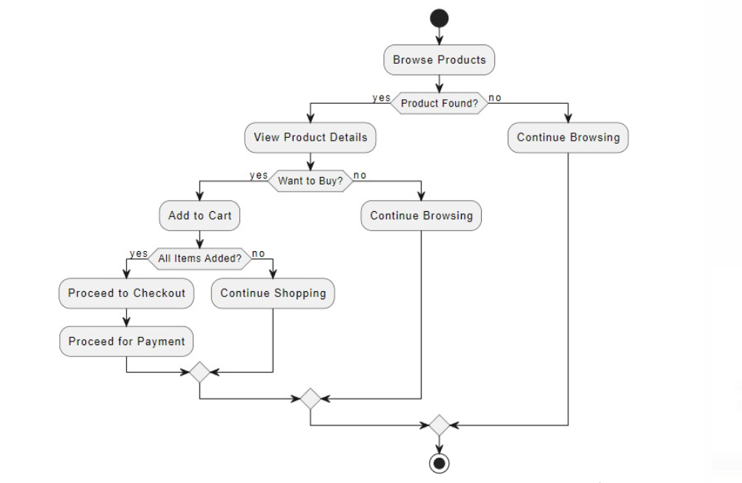5.3.1. Activity Diagram

Figure 1: Customer Activity Diagram

**Figure 2: Selling/Renting Activity Diagram**

* + 1. Class Diagram

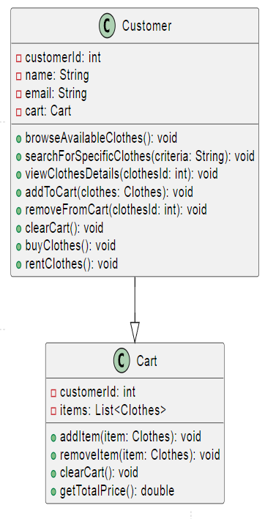

Figure 3: Apna Closet Class Diagram

* + 1. User Case Diagrams

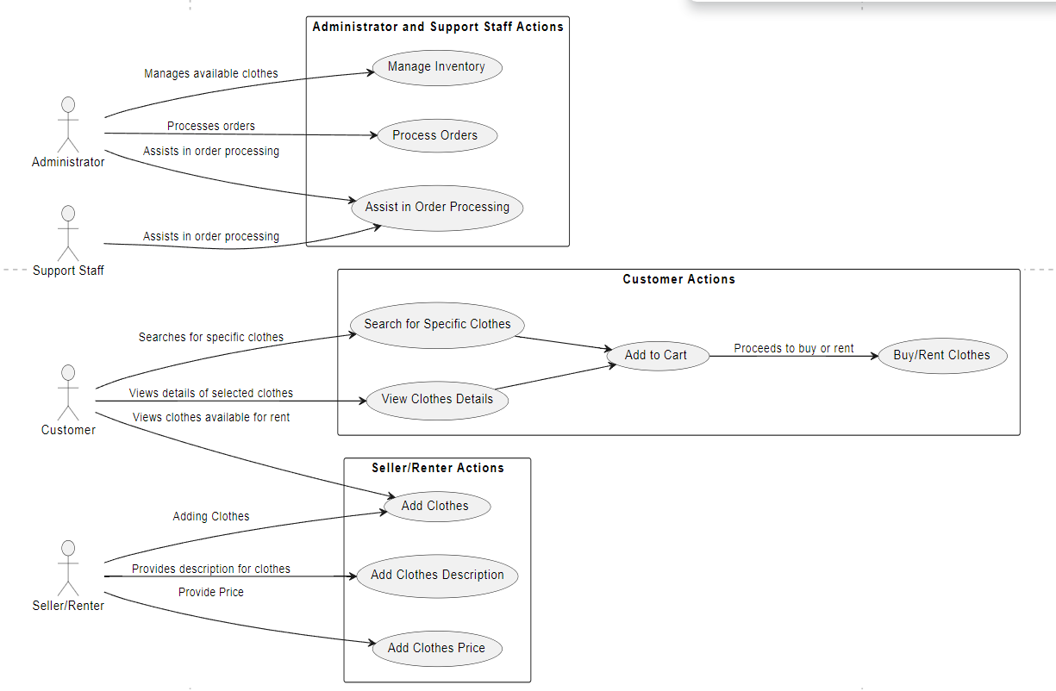

Figure 4: User Case Diagram for Apna Closet.

* + 1. Sequence Diagram

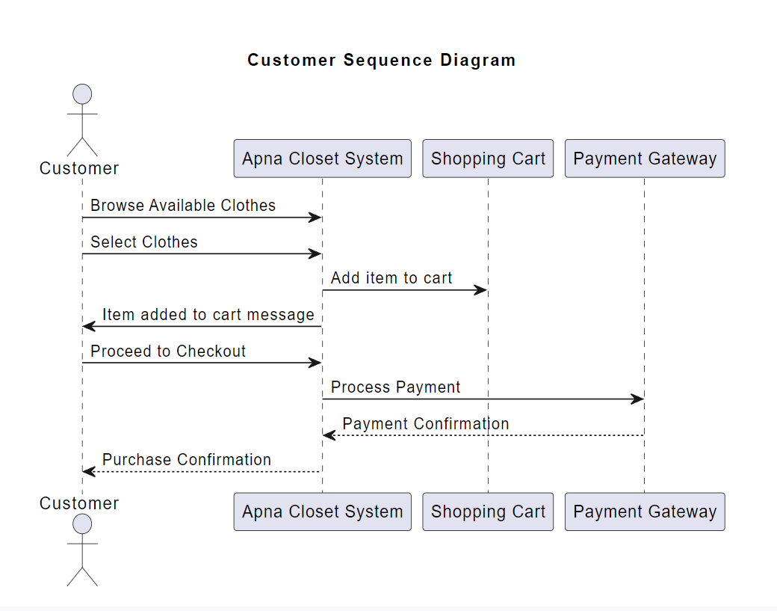

Figure 5: Customer Sequence Diagram

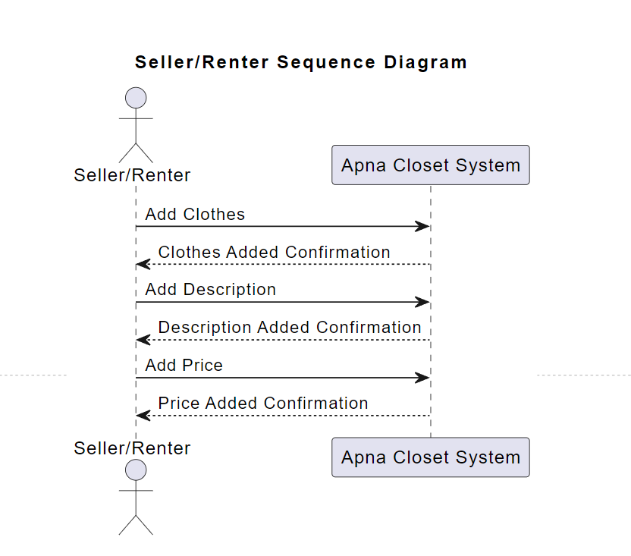

Figure 6: Seller/Renter Sequence Diagram

[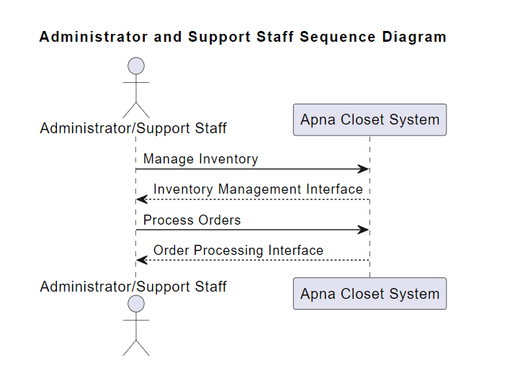](DTI%20Project%20Final%20Report%20Template%20(1).docx)

Figure 7: Admin Sequence Diagram

1. User Interface
   1. UI Description

For the Apna closet project, the user interface (UI) will primarily be a web-based application accessible through standard web browsers. Users, including customers, sellers/renters, administrators, and support staff, will interact with the program through a visually appealing and user-friendly interface. The UI will feature intuitive navigation menus, interactive forms, and visually pleasing layouts to enhance the user experience.

Customers will browse available clothes, search for specific items, view detailed information about each item, and proceed to rent or purchase clothes through the UI. Sellers/renters will have functionalities to add new clothes, provide descriptions and prices, manage their inventory, and process orders. Administrators and support staff will access the UI to manage inventory, process orders, and provide assistance as needed.

The UI will incorporate responsive design principles to ensure compatibility across various devices, including desktop computers, laptops, tablets, and smartphones. It will leverage modern web technologies such as html5, css3, and JavaScript to deliver dynamic and interactive features to users. Additionally, the UI may utilize frameworks like bootstrap or material design to achieve consistent styling and layout across different screens and resolutions. Overall, the UI will aim to provide a seamless and enjoyable experience for all users interacting with the Apna closet platform.

The user interface of the Apna Closet project plays a crucial role in providing an intuitive and engaging experience for all stakeholders involved, including customers, sellers/renters, administrators, and support staff. By leveraging modern web technologies and responsive design principles, we aim to create a user-friendly platform that simplifies the process of browsing, renting, and managing clothes while ensuring security, accessibility, and reliability. Our commitment to delivering a seamless and enjoyable user experience reflects our dedication to making Apna Closet a preferred destination for online clothing rental and purchase.

6.2 UI Mockup

Image 1:Log In page

](https://bennettu-my.sharepoint.com/personal/ehtesham_bennett_edu_in/Documents/Desktop/Project%20Bennett/PPT%20Template.pptx?web=1)

Image 2: Buy and Add to Cart Page

Image 3: Buy and Add to Cart option

Image 2: Home Page

Image 3: Home Page

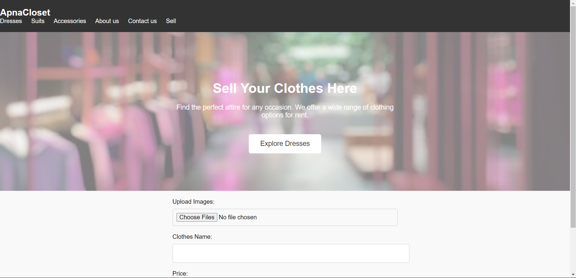

Image 4: Sell Clothes

Image 4: Rent Clothes

Image 5: Rent Clothes

Image 5: Sell Clothes

Image 6: Contact Page

1. Algorithms/Pseudo Code

**Algorithm: BrowseAvailableClothes**

Input: None

Output: List of available clothes

1. Retrieve list of available clothes from the database.

2. If the list is empty, display a message indicating that there are no available clothes.

3. Else, display the available clothes in a user-friendly format.

4. Allow the user to filter and sort the list based on various criteria such as size, color, style, and price.

5. If the user selects a specific item:

5.1 Display detailed information about the selected item.

5.2 Provide options for the user to rent or buy the item.

6. End

**Algorithm: AddClothes**

Input: Clothes details (name, description, size, color, price)

Output: Success message or error

1. Prompt the seller/renter to enter details of the clothes.

2. Validate the input fields to ensure all required information is provided.

3. If any field is missing or invalid, display an error message and return to step 1.

4. Add the clothes details to the database.

5. Display a success message indicating that the clothes have been added successfully.

6. End

**Algorithm: ProcessOrders**

Input: Order details (customer ID, clothes ID, order type)

Output: Success message or error

1. Retrieve the order details from the user interface.

2. Validate the input fields to ensure all required information is provided.

3. If any field is missing or invalid, display an error message and return to step 1.

4. Check the availability of the selected clothes.

5. If the clothes are available:

5.1 Reserve the clothes for the customer.

5.2 Update the inventory to reflect the reserved items.

5.3 Notify the customer about the order status.

6. If the clothes are not available, display a message indicating that the item is out of stock.

7. End

**Algorithm: ManageInventory**

Input: Inventory action (add, update, remove)

Output: Success message or error

1. Retrieve the inventory action from the user interface.

2. Perform the corresponding action based on the user input:

- If adding new inventory:

- Prompt the user to enter details of the new inventory.

- Add the inventory to the database.

- If updating existing inventory:

- Prompt the user to select the inventory to update.

- Allow the user to modify the inventory details.

- Update the database with the modified details.

- If removing inventory:

- Prompt the user to select the inventory to remove.

- Remove the selected inventory from the database.

3. Display a success message indicating that the inventory has been managed successfully.

4. End

1. Project Closure
   1. Goals / Vision

Our original vision for the Apna closet project was to create an innovative online platform that revolutionizes the way individuals’ access and exchange clothing items. Initially, our goals centered around developing a user-friendly interface for customers to browse, rent, and purchase clothing, while also providing sellers/renters with tools to manage their inventory effectively. However, as the project progressed, we realized the potential to expand our vision further.

Our revised vision encompasses not only the creation of a dynamic marketplace for clothing but also the integration of advanced recommendation algorithms to personalize the shopping experience for each user. We aim to leverage machine learning techniques to analyze user preferences and behavior, enabling us to offer tailored clothing recommendations and enhance customer satisfaction.

Furthermore, our vision extends beyond the platform itself to encompass sustainability and social responsibility. We aspire to promote eco-friendly practices within the fashion industry by encouraging the reuse and recycling of clothing items. Through collaborative partnerships and community engagement, we envision Apna closet as not just a marketplace but a catalyst for positive change in the fashion ecosystem."

This updated vision statement reflects our refined objectives and broader aspirations for the Apna closet project, emphasizing innovation, personalization, sustainability, and social impact.

* 1. Delivered Solution

Our goal with Apna closet was to create an awesome online hub where folks could easily find cool clothes to rent or buy. We wanted it to be super easy for both shoppers and folks who wanted to share their own outfits. Think of it like your favorite shopping app, but with a twist – you can rent clothes too!

Well, we built a website that's like your personal fashion paradise. You can browse through tons of different styles, search for specific items, and even get personalized recommendations based on what you like. And if you're a fashionista looking to share your wardrobe, we've got you covered too. Our platform lets you upload pictures and descriptions of your clothes, set your rental prices, and keep track of all your transactions.

* 1. Remaining Work

As we wrap up Apna Closet, there are still a few things left on our to-do list. While the website is up and running smoothly, there's always room for improvement. One thing we'd love to add is a feature that allows users to create wish lists and share their favorite finds with friends. We also want to enhance the search functionality to make it even easier for users to discover the perfect outfit. Moreover, proper integration of an Artificial intelligence model that can classify clothes as well as remove clothes from the web if found to have false descriptions using our cloth classifier model is essential. Alongside, integrating a fully functional recommendation system which can present you with the best choice of clothes based on your preferences and browsing history will enhance the user experience and satisfaction.**REFERENCES**

1. ThredUp. (2024). Online Thrift & Consignment Store. Retrieved from <https://www.thredup.com/>

2. Poshmark. (2024). Buy and Sell Fashion. Retrieved from <https://poshmark.com/>

3. The RealReal. (2024). Luxury Consignment Sales. Shop for pre-loved designer fashion. Retrieved from <https://www.therealreal.com/>

4. Rebag. (2024). Buy & Sell Pre-Owned Luxury Fashion. Retrieved from <https://www.rebag.com/>

5. McKinsey & Company. (2024). Style that’s sustainable: A new fast-fashion formula. Retrieved from <https://www.mckinsey.com/business-functions/sustainability/our-insights/style-thats-sustainable-a-new-fast-fashion-formula>